**Unraveling The Intricate Dialogue: Serotonin And The Gut Microbiome In Health And Disease**

### Dr. Youssef Benali

### Department of Neuroscience, Faculty of Medicine and Pharmacy, University Hassan II of Casablanca, Morocco

### Dr. Salma El Idrissi

### Laboratory of Microbial Ecology and Biotechnology, Cadi Ayyad University, Marrakech, Morocco

**Published Date: 13 December 2024 // Page no.: - 18-24**

## ABSTRACT

The gastrointestinal tract is a dynamic ecosystem where the gut microbiome and host-produced serotonin (5-HT) engage in complex bidirectional communication, profoundly impacting health and disease. This review highlights the critical role of the gut microbiome in modulating intestinal serotonin biosynthesis and metabolism, primarily through tryptophan processing and the production of microbial metabolites like short-chain fatty acids. Conversely, serotonin influences the gut microbial environment by regulating gut motility, secretion, and immune responses. Dysregulation within this serotonin-gut microbiome axis is implicated in various conditions, including gastrointestinal disorders, neuropsychiatric conditions (e.g., depression, anxiety), and metabolic diseases. Understanding these intricate interactions is crucial for developing novel therapeutic strategies to modulate this axis for improved health outcomes.

**Keywords:** Serotonin, Gut Microbiome, Tryptophan, Enterochromaffin Cells, Gut-Brain Axis, Short-Chain Fatty Acids, Intestinal Motility, Dysbiosis.

## INTRODUCTION

The human gastrointestinal tract is a complex ecosystem, home to trillions of microorganisms collectively known as the gut microbiome [1]. This microbial community plays a pivotal role in human health, influencing metabolism, immune function, and even brain development and function [2, 3, 4, 5, 6]. Concurrently, the gut is the primary site of serotonin (5-hydroxytryptamine, 5-HT) synthesis and storage, with approximately 95% of the body's total serotonin residing in the enterochromaffin (EC) cells of the intestinal mucosa [7, 8]. Serotonin, a well-known neurotransmitter in the central nervous system, also acts as a critical signaling molecule in the periphery, regulating various gastrointestinal (GI) functions, including motility, secretion, and sensation [9, 10, 11, 12].

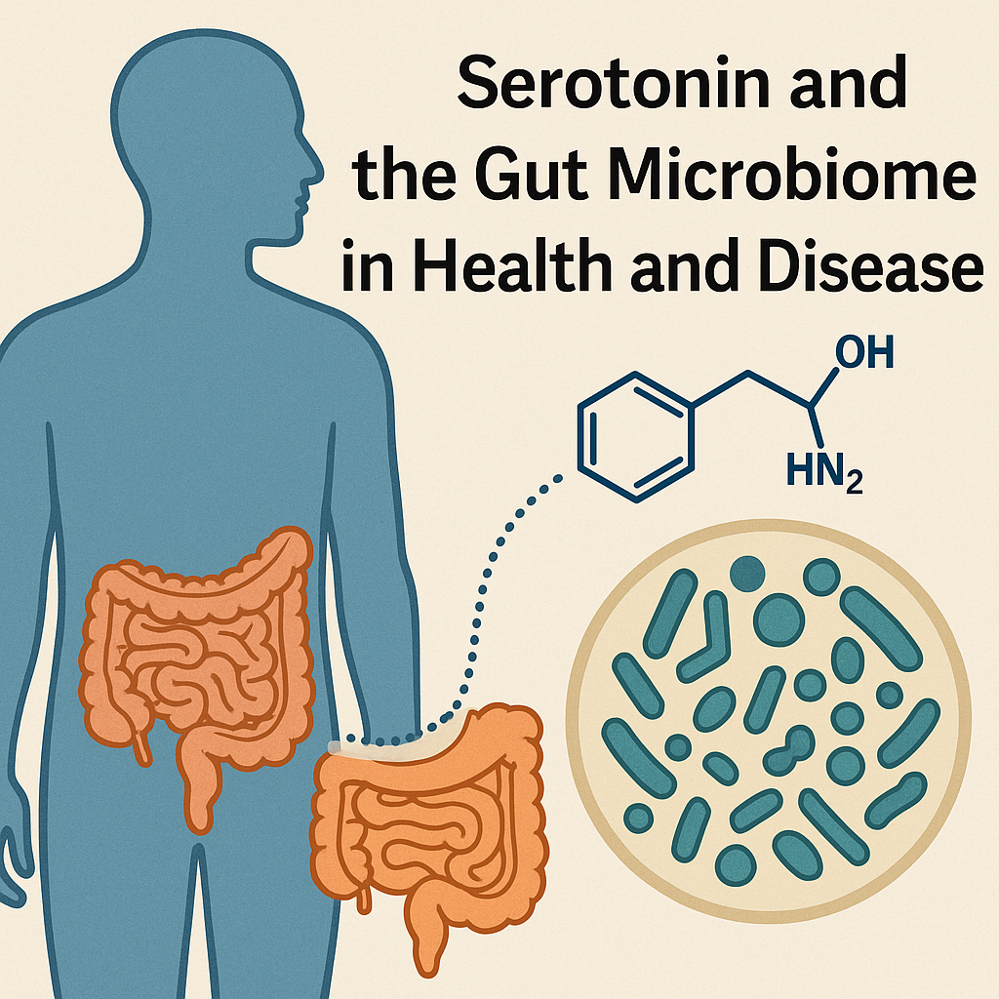

Emerging evidence suggests a profound and bidirectional interaction between intestinal serotonin and the gut microbiome [7, 8, 9]. This intricate dialogue is central to understanding the physiological regulation of gut function and its broader implications for host health, including mental health and metabolic homeostasis [4, 27, 28]. Dysregulation of either serotonin signaling or the gut microbiome has been implicated in a range of disorders, from irritable bowel syndrome (IBS) to depression and anxiety [7, 9, 29]. This article aims to comprehensively review the current understanding of the complex interplay between intestinal serotonin and the gut microbiome, exploring the mechanisms by which they influence each other and their collective impact on host physiology.

**METHODS**

This review article synthesizes findings from a broad range of scientific literature focusing on the interaction between intestinal serotonin and the gut microbiome. A comprehensive search was conducted across PubMed, utilizing keywords such as "serotonin," "gut microbiome," "enterochromaffin cells," "tryptophan," "short-chain fatty acids," "gut-brain axis," and "neurotransmitters." Emphasis was placed on studies investigating the synthesis, release, and function of serotonin in the gut, as well as the mechanisms by which gut microbes influence serotonin levels and signaling. Conversely, studies examining the effects of serotonin on microbial composition and function were also included. The selected references encompass original research articles, review articles, and systematic reviews to provide a holistic perspective on this rapidly evolving field.

**RESULTS**

Serotonin: A Key Regulator of Gut Function and Beyond

Serotonin is synthesized from the essential amino acid L-tryptophan by the enzyme tryptophan hydroxylase (TPH) [18]. In the gut, TPH1 is the predominant isoform expressed in EC cells [10, 19]. Once synthesized, serotonin is stored in vesicles within EC cells and released into the lamina propria, lumen, or bloodstream in response to various stimuli, including mechanical distension, chemical irritants, and microbial metabolites [12, 15, 16].

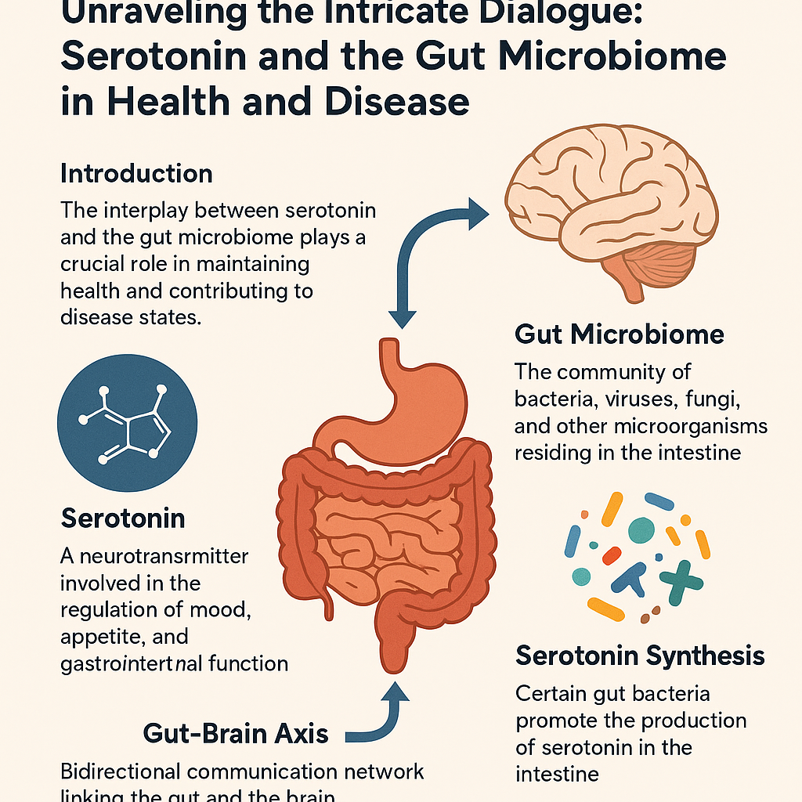

In the GI tract, serotonin exerts its diverse effects by binding to a multitude of serotonin receptors (5-HTRs), of which at least seven distinct families (5-HT1 to 5-HT7) with numerous subtypes have been identified [21, 23]. These receptors are expressed on various cell types, including neurons, immune cells, and epithelial cells, mediating a wide array of physiological responses. For instance, serotonin stimulates gut motility and accelerates colonic transit through activation of 5-HT3 and 5-HT4 receptors on enteric neurons [16, 20, 30]. It also plays a role in regulating intestinal secretion and influencing visceral sensation [15, 16]. Beyond the gut, peripheral serotonin has been implicated in metabolic homeostasis, cardiovascular function, and bone remodeling [26, 27].

Gut Microbiome's Influence on Intestinal Serotonin

A growing body of evidence highlights the significant impact of the gut microbiome on host serotonin biosynthesis and metabolism. Several mechanisms have been proposed to explain this influence:

• Direct Regulation of Tryptophan Metabolism: The gut microbiome plays a crucial role in tryptophan metabolism, which directly impacts serotonin synthesis. Gut microbes can metabolize tryptophan into various compounds, including indoles, tryptamine, and indole derivatives, which can then influence host physiology [17, 32]. Importantly, some indigenous gut bacteria have been shown to directly regulate host serotonin biosynthesis [10]. Studies have demonstrated that the presence of specific microbial communities can alter the expression of TPH1 in EC cells, thereby influencing serotonin production [10, 11]. For example, certain bacteria can produce short-chain fatty acids (SCFAs), such as butyrate, which can promote colonic serotonin production by influencing EC cells [11, 38, 39]. Butyrate, a key bacterial metabolite, has been shown to regulate the expression of ZBP-89, a transcription factor involved in TPH1 gene expression [40, 42].

• Microbial Production of Serotonin Precursors or Mimics: While direct microbial synthesis of serotonin is generally considered negligible, some gut bacteria can produce compounds that are structurally similar to serotonin or its precursors, such as tryptamine [24, 33]. Tryptamine, produced by certain gut microbiota, can activate specific G-protein-coupled receptors on epithelial cells, leading to increased colonic secretion [24]. While not serotonin itself, these microbial metabolites can interact with host signaling pathways that intersect with serotonergic systems, potentially modulating gut function and even the host's perception [34, 37].

• Modulation of Host Gene Expression: The gut microbiome can indirectly affect serotonin levels by modulating the expression of host genes involved in serotonin synthesis, transport, and degradation. For instance, germ-free mice exhibit significantly reduced levels of serotonin in the gut, which can be restored upon colonization with a conventional gut microbiota [10, 43]. This suggests that microbial signals are essential for the normal development and function of the intestinal serotonergic system.

Serotonin's Influence on the Gut Microbiome

The relationship between serotonin and the gut microbiome is bidirectional, meaning that serotonin itself can also influence the composition and function of the gut microbial community:

• Direct Antimicrobial Effects: While not their primary function, some neurotransmitters, including serotonin, can exhibit antimicrobial properties at certain concentrations. This could potentially influence the growth and survival of specific bacterial species in the gut lumen.

• Modulation of Gut Environment: Serotonin's influence on gut motility and secretion can indirectly affect the gut microbial environment. Changes in transit time, pH, and nutrient availability, all of which are influenced by serotonin, can alter the ecological niche for different microbial species, thereby shaping the gut microbiome composition [31].

• Impact on Host Immunity and Barrier Function: Serotonin plays a role in regulating intestinal immune responses and maintaining gut barrier integrity [29]. Dysregulation of these processes can lead to inflammation and altered microbial communities, creating a feedback loop where serotonin signaling and microbial composition mutually influence each other. Recent research has shown that intestinal serotonin and exposure to serotonergic drugs like fluoxetine can modulate bacterial colonization in the gut, further emphasizing this direct link [44].

The Serotonin-Gut Microbiome Axis and Disease

The intricate interplay between intestinal serotonin and the gut microbiome has significant implications for various physiological processes and disease states:

• Gut-Brain Axis and Mental Health: The gut-brain axis is a complex communication network linking the central nervous system with the enteric nervous system and the gut [9]. Both serotonin and the gut microbiome are key players in this axis. Alterations in gut microbial composition (dysbiosis) and dysregulation of serotonin signaling have been strongly implicated in the pathogenesis of neuropsychiatric disorders such as depression, anxiety, and autism spectrum disorders [4, 9, 28, 36]. The gut microbiome can influence brain serotonergic activity through the production of neuroactive metabolites and by affecting systemic tryptophan availability [8, 18]. Conversely, changes in brain serotonin levels or pharmacological interventions targeting serotonin can influence gut microbiota composition [44].

• Gastrointestinal Disorders: Conditions like Irritable Bowel Syndrome (IBS) are often characterized by altered gut motility, visceral hypersensitivity, and dysbiosis [7, 16]. Serotonin signaling abnormalities, particularly in EC cell function and serotonin transporter activity, are frequently observed in IBS patients. The gut microbiome is increasingly recognized as a contributing factor to IBS symptoms, with specific microbial profiles being associated with different IBS subtypes. The dysfunctional interaction between serotonin and the gut microbiome likely contributes to the pathophysiology of these disorders [31].

• Metabolic Diseases: Emerging research suggests a link between the gut microbiome, serotonin, and metabolic health. Serotonin in the periphery influences glucose homeostasis and fat metabolism [27]. Changes in gut microbial composition and their metabolic output can impact host serotonin levels, potentially contributing to metabolic disorders [35].

**DISCUSSION**

The bidirectional communication between intestinal serotonin and the gut microbiome represents a fundamental aspect of host-microbe interactions. The gut microbiome significantly influences the biosynthesis and metabolism of host serotonin, primarily by modulating tryptophan availability and regulating the activity of EC cells through metabolites like SCFAs [10, 11, 39]. This influence extends to shaping the overall gut serotonergic tone, which in turn impacts various physiological functions from motility to sensation. Conversely, serotonin itself can directly or indirectly influence the gut microbial ecosystem by affecting gut physiology and potentially exhibiting subtle antimicrobial effects [29, 31, 44].

The implications of this intricate dialogue are far-reaching. The serotonin-gut microbiome axis is increasingly recognized as a critical player in the gut-brain axis, impacting mental health and neurodevelopment [8, 28]. Dysregulation within this axis is a recurring theme in a variety of conditions, including functional gastrointestinal disorders, metabolic syndromes, and even neurodegenerative diseases [7, 9, 27, 45]. Understanding the specific microbial species and their metabolites that modulate serotonin pathways, and vice versa, offers promising avenues for therapeutic interventions.

Future research should focus on elucidating the precise molecular mechanisms underlying these interactions. This includes identifying specific microbial enzymes and metabolites that directly influence TPH1 activity or serotonin receptor expression, as well as characterizing the effects of different serotonin receptor subtypes on microbial growth and colonization dynamics. Furthermore, longitudinal studies in humans are needed to establish causal relationships between specific microbial shifts, serotonin alterations, and disease progression. The development of targeted prebiotics, probiotics, or postbiotics that modulate the serotonin-gut microbiome axis holds immense potential for addressing a wide range of health challenges.

**CONCLUSION**

The interaction between intestinal serotonin and the gut microbiome is a dynamic and mutually influential relationship critical for maintaining gut homeostasis and overall host health. The gut microbiome exerts a substantial influence on host serotonin production and metabolism, primarily through tryptophan catabolism and the production of metabolites such as short-chain fatty acids. In turn, serotonin, by regulating gut physiology, can modulate the gut microbial environment. Disruptions in this delicate balance have profound implications for gastrointestinal health, mental well-being, and metabolic regulation. Further unraveling the complexities of this bidirectional communication will pave the way for novel therapeutic strategies targeting the serotonin-gut microbiome axis for disease prevention and treatment.

**REFERENCES**

[1]. Gill SR, Pop M, Deboy RT, Eckburg PB, Turnbaugh PJ, Samuel BS, et al. Metagenomic analysis of the human distal gut microbiome. Science. 2006 Jun 2;312(5778):1355-9. Pubmed PMID: 16741115.

[2]. Walter J, Ley R. The human gut microbiome: ecology and recent evolutionary changes. Annu Rev Microbiol. 2011;65:411-29. Pubmed PMID: 21682646.

[3]. Singh RK, Chang HW, Yan D, Lee KM, Ucmak D, Wong K, et al. Influence of diet on the gut microbiome and implications for human health. J Transl Med. 2017 Apr 8;15(1):73. Pubmed PMID: 28388917.

[4]. Peirce JM, Alviña K. The role of inflammation and the gut microbiome in depression and anxiety. J Neurosci Res. 2019 Oct;97(10):1223-1241. Pubmed PMID: 31144383.

[5]. Dominguez-Bello MG, De Jesus-Laboy KM, Shen N, Cox LM, Amir A, Gonzalez A, et al. Partial restoration of the microbiota of cesarean-born infants via vaginal microbial transfer. Nat Med. 2016 Mar;22(3):250-3. Pubmed PMID: 26828196.

[6]. David LA, Maurice CF, Carmody RN, Gootenberg DB, Button JE, Wolfe BE, et al. Diet rapidly and reproducibly alters the human gut microbiome. Nature. 2014 Jan 23;505(7484):559-63. Pubmed PMID: 24336217.

[7]. Szőke H, Kovács Z, Bókkon I, Vagedes J, Szabó AE, Hegyi G, et al. Gut dysbiosis and serotonin: intestinal 5-HT as a ubiquitous membrane permeability regulator in host tissues, organs, and the brain. Rev Neurosci. 2020 May 26;31(4):415-425. Pubmed PMID: 32007948.

[8]. O'Mahony SM, Clarke G, Borre YE, Dinan TG, Cryan JF. Serotonin, tryptophan metabolism and the brain-gut-microbiome axis. Behav Brain Res. 2015 Jan 15;277:32-48. Pubmed PMID: 25078296.

[9]. Rogers GB, Keating DJ, Young RL, Wong ML, Licinio J, Wesselingh S. From gut dysbiosis to altered brain function and mental illness: mechanisms and pathways. Mol Psychiatry. 2016 Jun;21(6):738-48. Pubmed PMID: 27090305.

[10]. Yano JM, Yu K, Donaldson GP, Shastri GG, Ann P, Ma L, et al. Indigenous bacteria from the gut microbiota regulate host serotonin biosynthesis. Cell. 2015 Apr 9;161(2):264-76. Pubmed PMID: 25860609.

[11]. Reigstad CS, Salmonson CE, Rainey JF 3rd, Szurszewski JH, Linden DR, Sonnenburg JL, et al. Gut microbes promote colonic serotonin production through an effect of short-chain fatty acids on enterochromaffin cells. FASEB J. 2015 Apr;29(4):1395-403. Pubmed PMID: 25550456.

[12]. Bellono NW, Bayrer JR, Leitch DB, Castro J, Zhang C, O'Donnell TA, et al. Enterochromaffin Cells Are Gut Chemosensors that Couple to Sensory Neural Pathways. Cell. 2017 Jun 29;170(1):185-198.e16. Pubmed PMID: 28648659.

[13]. Bunnett NW. Neuro-humoral signalling by bile acids and the TGR5 receptor in the gastrointestinal tract. J Physiol. 2014 Jul 15;592(14):2943-50. Pubmed PMID: 24614746.

[14]. Berger M, Gray JA, Roth BL. The expanded biology of serotonin. Annu Rev Med. 2009;60:355-66. Pubmed PMID: 19630576.

[15]. Gershon MD. 5-Hydroxytryptamine (serotonin) in the gastrointestinal tract. Curr Opin Endocrinol Diabetes Obes. 2013 Feb;20(1):14-21. Pubmed PMID: 23222853.

[16]. Gershon MD, Tack J. The serotonin signaling system: from basic understanding to drug development for functional GI disorders. Gastroenterology. 2007 Jan;132(1):397-414. Pubmed PMID: 17241888.

[17]. Wikoff WR, Anfora AT, Liu J, Schultz PG, Lesley SA, Peters EC, et al. Metabolomics analysis reveals large effects of gut microflora on mammalian blood metabolites. Proc Natl Acad Sci U S A. 2009 Mar 10;106(10):3698-703. Pubmed PMID: 19234110.

[18]. Höglund E, Øverli Ø, Winberg S. Tryptophan Metabolic Pathways and Brain Serotonergic Activity: A Comparative Review. Front Endocrinol (Lausanne). 2019 Apr 8;10:158. Pubmed PMID: 31024440.

[19]. Kitahama K, Ikemoto K, Jouvet A, Araneda S, Nagatsu I, Raynaud B, et al. Aromatic L-amino acid decarboxylase-immunoreactive structures in human midbrain, pons, and medulla. J Chem Neuroanat. 2009 Oct;38(2):130-40. Pubmed PMID: 19589383.

[20]. Heredia DJ, Gershon MD, Koh SD, Corrigan RD, Okamoto T, Smith TK. Important role of mucosal serotonin in colonic propulsion and peristaltic reflexes: in vitro analyses in mice lacking tryptophan hydroxylase 1. J Physiol. 2013 Dec 1;591(23):5939-57. Pubmed PMID: 24127620.

[21]. Nichols DE, Nichols CD. Serotonin receptors. Chemical reviews. 2008 May 14;108(5):1614-41.

[22]. Lund ML, Egerod KL, Engelstoft MS, Dmytriyeva O, Theodorsson E, Patel BA, et al. Enterochromaffin 5-HT cells - A major target for GLP-1 and gut microbial metabolites. Mol Metab. 2018 May;11:70-83. Pubmed PMID: 29576437.

[23]. Thompson AJ, Lummis SC. 5-HT3 receptors. Curr Pharm Des. 2006;12(28):3615-30. Pubmed PMID: 17073663.

[24]. Bhattarai Y, Williams BB, Battaglioli EJ, Whitaker WR, Till L, Grover M, et al. Gut Microbiota-Produced Tryptamine Activates an Epithelial G-Protein-Coupled Receptor to Increase Colonic Secretion. Cell Host Microbe. 2018 Jun 13;23(6):775-785.e5. Pubmed PMID: 29902441.

[25]. Folk GE Jr, Long JP. Serotonin as a neurotransmitter: a review. Comp Biochem Physiol C Comp Pharmacol Toxicol. 1988;91(1):251-7. Pubmed PMID: 2905227.

[26]. Vanhoutte PM. Serotonin: beyond the brain. ACS Chem Neurosci. 2013 Jan 16;4(1):26-7. Pubmed PMID: 23336041.

[27]. El-Merahbi R, Löffler M, Mayer A, Sumara G. The roles of peripheral serotonin in metabolic homeostasis. FEBS Lett. 2015 Jul 8;589(15):1728-34. Pubmed PMID: 26070423.

[28]. Clarke G, Grenham S, Scully P, Fitzgerald P, Moloney RD, Shanahan F, et al. The microbiome-gut-brain axis during early life regulates the hippocampal serotonergic system in a sex-dependent manner. Mol Psychiatry. 2013 Jun;18(6):666-73. Pubmed PMID: 22688187.

[29]. Kwon YH, Wang H, Denou E, Ghia JE, Rossi L, Fontes ME, et al. Modulation of Gut Microbiota Composition by Serotonin Signaling Influences Intestinal Immune Response and Susceptibility to Colitis. Cell Mol Gastroenterol Hepatol. 2019;7(4):709-728. Pubmed PMID: 30716420.

[30]. Tsukamoto K, Ariga H, Mantyh C, Pappas TN, Yanagi H, Yamamura T, et al. Luminally released serotonin stimulates colonic motility and accelerates colonic transit in rats. Am J Physiol Regul Integr Comp Physiol. 2007 Jul;293(1):R64-9. Pubmed PMID: 17442783.

[31]. Ge X, Pan J, Liu Y, Wang H, Zhou W, Wang X. Intestinal Crosstalk between Microbiota and Serotonin and its Impact on Gut Motility. Curr Pharm Biotechnol. 2018;19(3):190-195. Pubmed PMID: 29804531.

[32]. Bosi A, Banfi D, Bistoletti M, Giaroni C, Baj A. Tryptophan Metabolites Along the Microbiota-Gut-Brain Axis: An Interkingdom Communication System Influencing the Gut in Health and Disease. Int J Tryptophan Res. 2020 Jun 11;13:1178646920928984. Pubmed PMID: 32577079.

[33]. Williams BB, Van Benschoten AH, Cimermancic P, Donia MS, Zimmermann M, Taketani M, et al. Discovery and characterization of gut microbiota decarboxylases that can produce the neurotransmitter tryptamine. Cell Host Microbe. 2014 Oct 8;16(4):495-503. Pubmed PMID: 25263219.

[34]. Takaki M, Mawe GM, Barasch JM, Gershon MD, Gershon MD. Physiological responses of guinea-pig myenteric neurons secondary to the release of endogenous serotonin by tryptamine. Neuroscience. 1985 Sep;16(1):223-40. Pubmed PMID: 2940472.

[35]. Marcobal A, Kashyap PC, Nelson TA, Aronov PA, Donia MS, Spormann A, et al. A metabolomic view of how the human gut microbiota impacts the host metabolome using humanized and gnotobiotic mice. ISME J. 2013 Oct;7(10):1933-43. Pubmed PMID: 23739052.

[36]. Jenkins TA, Nguyen JC, Polglaze KE, Bertrand PP. Influence of Tryptophan and Serotonin on Mood and Cognition with a Possible Role of the Gut-Brain Axis. Nutrients. 2016 Jan 20;8(1):56. Pubmed PMID: 26805875.

[37]. Yang NJ, Chiu IM. Bacterial Signaling to the Nervous System through Toxins and Metabolites. J Mol Biol. 2017 Mar 10;429(5):587-605. Pubmed PMID: 28065740.

[38]. Topping DL, Clifton PM. Short-chain fatty acids and human colonic function: roles of resistant starch and nonstarch polysaccharides. Physiol Rev. 2001 Jul;81(3):1031-64. Pubmed PMID: 11427691.

[39]. Koh A, De Vadder F, Kovatcheva-Datchary P, Bäckhed F. From Dietary Fiber to Host Physiology: Short-Chain Fatty Acids as Key Bacterial Metabolites. Cell. 2016 Jun 2;165(6):1332-1345. Pubmed PMID: 27259147.

[40]. Essien BE, Grasberger H, Romain RD, Law DJ, Veniaminova NA, Saqui-Salces M, et al. ZBP-89 regulates expression of tryptophan hydroxylase I and mucosal defense against Salmonella typhimurium in mice. Gastroenterology. 2013 Jun;144(7):1466-77, 1477.e1-9. Pubmed PMID: 23395646.

[41]. Savelieva KV, Zhao S, Pogorelov VM, Rajan I, Yang Q, Cullinan E, et al. Genetic disruption of both tryptophan hydroxylase genes dramatically reduces serotonin and affects behavior in models sensitive to antidepressants. PLoS One. 2008;3(10):e3301. Pubmed PMID: 18923670.

[42]. Bai L, Merchant JL. Transcription factor ZBP-89 cooperates with histone acetyltransferase p300 during butyrate activation of p21waf1 transcription in human cells. J Biol Chem. 2000 Sep 29;275(39):30725-33. Pubmed PMID: 10899165.

[43]. Hata T, Asano Y, Yoshihara K, Kimura-Todani T, Miyata N, Zhang XT, et al. Regulation of gut luminal serotonin by commensal microbiota in mice. PLoS One. 2017 Jul 6;12(7):e0180745. Pubmed PMID: 28683093.

[44]. Fung TC, Vuong HE, Luna CDG, Pronovost GN, Aleksandrova AA, Riley NG, et al. Intestinal serotonin and fluoxetine exposure modulate bacterial colonization in the gut. Nat Microbiol. 2019 Dec;4(12):2064-2073. Pubmed PMID: 31477894.

[45]. Sochocka M, Donskow-Łysoniewska K, Diniz BS, Kurpas D, Brzozowska E, Leszek J. The Gut Microbiome Alterations and Inflammation-Driven Pathogenesis of Alzheimer's Disease-a Critical Review. Mol Neurobiol. 2019 Mar;56(3):1841-1851. Pubmed PMID: 29936690.